07.03 Work Templates
Process Design & AMOS Configuration Document
Revision
Author, Name | Date | Notes
Frederic LURIN | 21/12/2024 | Initial definition

Purpose
This Process Design document is provided to Key-Users to record their key decisions regarding the AMOS Process design and the required AMOS configuration.
It is updated throughout the Project Definition Phase and used as the baseline for the Final Acceptance prior to Go-Live

Table of Contents
1. Process Overview & Objectives 3
2. Regulatory References 4
3. Definitions & Glossary 4
4. Process Tasks 4
5. Process Dependencies 5
6. Process Flow 6
7. Process Design Questions 7
8. Data (Source) Mapping 8
9. Other Software Used 8
10. AMOS Configuration 9
a. Basic Data 9
b. Parameters 9
c. Workflows 9
d. Scheduled Tasks 10
e. API’s & Interfaces 10
11. Annex – Additional Info 11

Process Overview & Objectives

Process General Description:
This process is usually executed by the Production Engineering or Production Planning department of an MRO or an Airline.
The work template authoring process is a requirement to then be able to properly plan and execute maintenance events in AMOS. This process is continuously executed as it is run both at the initial creation of the work templates and at their revision.
The trigger for this process is the need to create or modify a work template for maintenance execution, and the output of this process are the work templates ready for planning and/or execution.
The main benefits identified for the organisation when fully adopting this process are the following:
- Overall Economy – cost reduction: As work templates are basically driving all the planning data and, consequently, also the planned allocation of resources, it is clear that accurate data will bring to an increase of the efficiency and to a consequent reduction of costs. In fact, accurate work templates will on one side protect the organization from the disruptions potentially caused by an under-estimation of the needed resources, on the other side will avoid potential inefficiencies in terms of financial budget, caused by an over-allocation of resources. Moreover, the accuracy of the work instructions, will avoid work interruptions and waste of manpower.
- Process improvement: If the work templates are accurate, the maintenance preparation and execution will be properly driven to the best standards.
- Internal management: With accurate work templates, the manpower both in engineering and maintenance will be optimized as this will reduce the interactions generated by unclear or incomplete information during the operational management.
- As maintenance program events also refer to work templates, the work templates can be edited on both through the maintenance program APN (APN 249) and the work template manager APN (APN 1848).
- It is important to clearly define appropriate user access rights to both APNs as the maintenance program APN is very sensitive with regards to the airworthiness of the aircraft managed inside.
- The work template authoring policy inside the organisation should clearly specify which department is responsible of which work template elements. Nevertheless, it is important to emphasize that although the CAMO is responsible to determine when a maintenance event is supposed to be performed, the MRO is the entity that has the required expertise to determine how the maintenance event should be planned and executed.

Main Process Objective (Outputs & Outcomes):
The main stake holder involved in this process is the Production Engineering or Production Planning department. This department is usually responsible for authoring the work instructions and updating them when required.
- Production Engineering/Planning is also usually the department that collects feedback on the work templates to continuously improve them.
- Work template creation and authoring is usually performed by users that have maintenance planning and maintenance execution experience. This allows them to efficiently create accurate templates that can easily be used in productive environments.
- Maintaining the work templates is an on-going process that requires continuous involvement of the department. The workload to setup the templates is usually high at the first implementation, but then reduces significantly when only revisions are required.
- The validation of the work templates after their creation may involve different level of users within the Production Engineering/Planning department.
- It is important to note that the CAMO/Engineering department is also involved in this process, as the creation and initialisation of an AMP event creates a basic work template that is associated to the event.

Regulatory References

The main benefits regulatory references identified for this process are the following:
- EASA Part-145 – 145.A.45 – Maintenance Data
- EASA Part-145 – 145.A.47 – Production Planning
- EASA Part-145 – 145.A.47 – Production Performance of Maintenance
- EASA Part-145 – 145.A.65 – Maintenance Procedures
- EASA Part-M – M.A.401 – Maintenance Data
- EASA Part-M – M.A.402 – Performance of Maintenance

Definitions & Glossary

Key-Words | Explanation
Workorder (W/O) | The workorder is the object were all maintenance activities are recorded. In connection with unscheduled maintenance all defect / malfunction are recorded in a workorder. The workorder can be created in different ways.
Job Card | Maintenance event that is usually linked to a parent event (WO, CR, or TC) and gets pulled in to a work package. Job cards are usually used for preparation and follow on items, or for complex tasks. Job cards can also be assigned to a workpackage as standalone maintenance execution items.
Task Card | Maintenance Event on maintenance forecast which is triggered by maintenance program requirement - this task card can be standalone on maintenance forecast and/or integrated in check
Customer requirements | Similar to Task Cards, Customer Requirements are maintenance events that are added into non-managed aircraft work packages, and are used for MRO activities.
Replacement Event | A Replacement Event is created in AMOS for each rotable, that has at least one requirement defined, which triggers the replacement of the component - rotable requirement or component document
Workpackage | The workpackage is the container for various maintenance events. Unscheduled and scheduled maintenance event can be included. Workpackages are handed over to the MRO to clearly define the scope of work.
Work Template | Work instructions which are saved as template. Main use case is the usage for scheduled maintenance events but there are also possibilities and use cases to use pre-defined templates for unscheduled maintenance.

Process Tasks

Main Process Task / Actions / Activities:
The following actions are performed in this Business Process:
- Prepare Work Template – Standalone/CustReq/CompReq: Generate a work template from scratch, without any information coming from manage aircraft maintenance program.
- This is done for customer requirements and is applicable to MROs maintaining 3rd party aircraft.
- This is also done for standalone work templates that can be prepared for ad-hoc events such as findings.
- This can also be done for component requirements which are linked to ad-hoc events such as shop work.
- In this action the user will generate a template linked to a specific scope (AMM, CMM or MPD item), link the relevant OEM document to it, add his resource requests including parts, tools and staff. The user should also add the relevant phases, panels, zones data to his template.
- Prepare Work Template – TC, Check, Part-Req or Mod: Update a work template already created from a managed aircraft maintenance program or document manager. This is applicable to managed aircraft. In this action the user will update the relevant work template, if required, link the relevant OEM document to it, add his resource requests including parts, tools and staff. The user should also add the relevant phases, panels, zones data to his template.
- Prepare Work Template – JobCard, ShopCard: Generate a work template from scratch for job cards and shop cards that can be linked to other events or assigned to a work package ad-hoc. This is generally used for preparation and close up tasks. In this action the user will generate a template linked to a specific scope (AMM, CMM or MPD item), link the relevant OEM document to it, add his resource requests including parts, tools and staff. The user should also add the relevant phases, panels, zones data to his template.
- Prepare/Save Workstep: This step is optional. This action consists of either preparing or saving a specific workstep inside the work step repository. This can be done if a specific work step is to be (re-)used on multiple work templates.
- Create/Link Jobcards as necessary: This step allows the user to link the relevant job cards previously prepared as individual work templates to a leading work templates. This will allow the collection of job cards when the leading work template is assigned to a workpackage.
- Create draft EWI: This step is optional: When using EWIs, work templates offer the possibility to create a draft EWIs for each individual work templates. Creating a draft EWI offers the possibility to customise the EWI before it is used in a work package. During this step the user can add additional information to the EWI, mark items as N/A, add additional stamp boxes etc... These elements will be carried over with the work template in the workpackage.
- Activate revision of the work template: In this step the suer finalises the authoring of the work template and by activating the revision, put into production all the changes brought to the work template.

Process Dependencies

- 02.05 – Technical Library: to be able to link documentation references inside your work templates, the documentation needs to be imported in the OEM documentation library before.
- 02.06 – Requirement Work Scoping: For managed aircraft, the event triggering maintenance is usually part of the aircraft maintenance program. The maintenance program event creates as baseline work template that then needs to be enhanced for execution and planning purposes.
- 03.02 – Work Package Generation: The work templates will feed information to the system when generating work packages
- 07.04 – Production Planning Preparation: The resource requests, breakdowns and durations defined in the Work Ttemplates will serve as inputs for the production planning preparation and capacity planning functions.

Process Flow
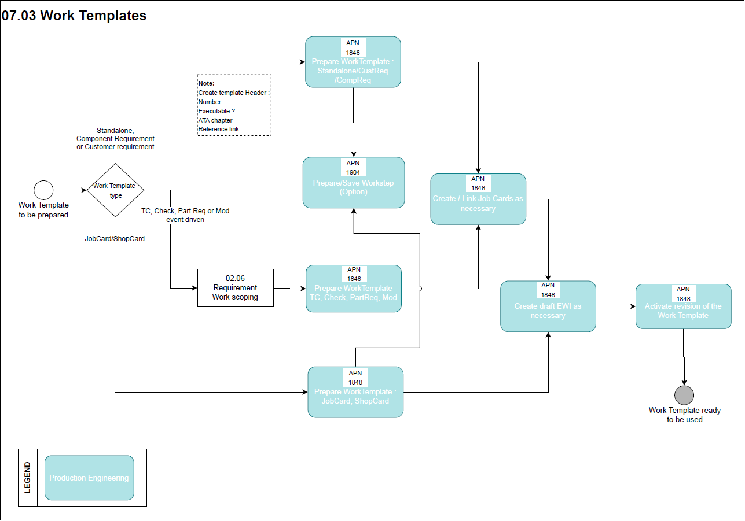
This flow chart is based on three different main paths:
- AMP/OMP and Modification driven events path: used for work templates linked to Checks, Documents, Parts, and Task cards events. The associated event type codes are: CHR, DO, PA, and TC.
- Standalone, Customer Requirement and Component requirement events path: used for work templates linked to Customer requirements, Component requirements and standalone work. The associated event type codes are: COR, CR and TW.
- Jobcard and Shopcard event path: used for work templates linked to Jobcards and Shopcards. The associated event type codes are: JC and SH.

Process Design Questions

# | Question | Answer
1 | How do you currently manage your customers WP's?
2 | Do you create internal documents to manage the Customer Requirements?
3 | Who is responsible to create Customer's non-managed Aircraft?
4 | Will the customer requirements be managed completely by production?

Data (Source) Mapping

Data Sources | Description | Volume / Manual / Automatic / Static / Dynamic
-Nil-

Other Software Used

Other Softwares | Used by: | Description
-Nil-

AMOS Configuration

The AMOS Configuration with regards to this process is extensive especially on the basic data setup aspect.

Basic Data

Basic Data Table | Notes
Planning Qualifications | To define Skill and Scope by staff specialty or qualification in order to properly perform a work instruction.  Skill e.g. : C, B1, B2 etc...  Scope : Mech., EIR, Cabin,
Meta Data Key | Basic Table to define the applicable meta keys which can be used when defining new meta data.  If a `Mime type` is added the user is able to choose the meta data value via book when adding a value
Standard Text | Defines replacements for the @STANDARD_TEXT@ and @STANDARD_HEADLINE@ wildcards of a work template.
Area Codes | This table contains all "area" codes which can be used for Jobcards (APN 1647).
Job Cards Groups | All available group codes for jobcards.
Note Codes | Own Note types can be defined here beside the predefined one e.g. the internal remarks or the closing message.  can only be used for Jobcards (APN 1647)
Panel Codes | This table contains all "panel" codes which can be used for Jobcards (APN 1647).
Section Codes | This table contains all "section" codes which can be used for Jobcards (APN 1647).
Special Codes | This table contains all "special" codes which can be used for Jobcards (APN 1647).
Zone Codes | This table contains all "zone" codes which can be used for Jobcards (APN 1647).

Parameters

Parameter Code | Parameter Name | Notes | Settings
1175 | Price per manhour in ms | The float value of this parameter contains the default price per manhour used in APN 58, Statistics tab to calculate the costs of a workpackage. | Float: As required
1396 | Related taskcard logic | By setting this parameter to `Y`, the Program "View/Edit Workpackage" will also collect maintenance events that are related one to another with the relation code `W`. | String: Y
1455 | Project number mandatory in workpackage | Sets the Project number field as mandatory in View/Edit Workpackage – this is configured in the Financial Congifuration APN | -/-
1470 | Workpackage groups settings | With this parameter you can control the behaviour of the workpackage groups. | Float: 0.00  Integer: 0  String: As required
1502 | Workpackage date | This parameter configures the behaviour of the WP date filter in the maintenance forecast and the default WP start and end time. | Float: 0.00  Integer: 0  String: 22:00;07:00
1523 | Workpackage assignment restrictions | This parameter influences the system behaviour for the assignment of Heavy classified items to a Line WP, and if a WO is automatically issued if a BTC is deassigned from a WP. | Float: 0.00  Integer: 0  String: As required
1529 | AMM of Workpackage | This parameter makes the AMM field mandatory for a WP. | Integer: 0
1537 | Default workpackage classification | This parameter sets the default classification of a WP | String: U
1548 | Show the electronic signature panel | The first parameter of the string value defines if the electronic signature panel is visible in APN 58, the second if it is visible in APN 3075. | String: Y;Y
1640 | WP information on PDF report | This parameter gives the possibility to print workpackage information to all PDF files linked to the Workpackage Summary reports. | Float: 0.00  Integer: 0  String: N
1650 | Workpackage number index | This parameter controls the automatic generation of workpackage numbers when creating workpackages. | Float: 0.00  Integer: 0  String: As required
1805 | Default Rounding Strategy for Resource Time Requirement | This parameter defines the default strategy used to round the time requirement in Quotation Manager, in the Commercial Tab of Work template manager and in Define commercial Man-Hours. This parameter is managed in Financial Configuration (APN 2365) | -/-
1878 | Work Step Wildcards Behaviour | This parameter allows the wildcard feature to be enabled or not and determines the behaviour of the wildcards in the work templates. | Float: 1.00  Integer: 0  String: “”

Workflows

Workflow Number | Workflow Name | Notes
230 | Work Template Modification | The workflow will be triggered whenever a Work Template is modified. The following actions are possible: CHANGED, DELETED or NEW (for each action a Template Rule exists). To differentiate between the Work Template Requirement References the wildcard “event_type” can be used.
390 | Work template Update Revision | The workflow will be triggered when 'Update Revision' function is performed. To differentiate between the Work Template Requirement References the wildcard “event_type” can be used.

Scheduled Tasks

Scheduled Task Reference | Frequency | Notes
WorkTemplateActivateRevisionService | As required

API’s & Interfaces

Reference | Direction | Trigger | Frequency
Transfer work template | Exchange work template data between two AMOS systems or with other systems – Import & Export
Export work template meta data grouping | Export work template meta data grouping from the AMOS environment - Export only

Annex – Additional Info

-Nil-

